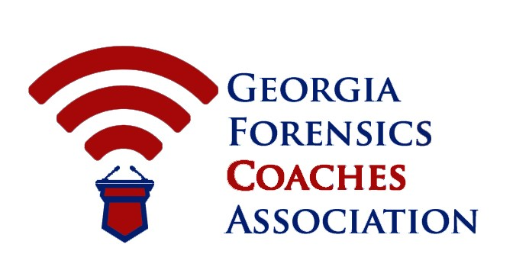
SPRING MEETING
April 21, 2018
Grady High School,
929 Charles Allen Dr NE, Atlanta, GA 30309
All meetings will be held in the C-Wing Computer Lab

9:00-9:15 a.m. Welcome and coffee

9:15- 12:00 p.m. Business Meeting Part I: Constitution and Meta Issues
- By-laws: Proposed clarifications of speech tabulation in the 4.37 section of by-laws under State (Wills)
- By-laws: Proposed section for Protests at State tournaments 4.40 (Wills)
- By-laws: Proposed amendment to select tabulation ‘by program deemed most reliable by Executive Committee on a year by year basis’ (S. Wang)
- By-laws: Proposed addition of process for selecting Impromptu topics for Varsity State (S. Wang)
- By-laws: Proposed change to 4.36- Judges will disclose decisions at the end of rounds at Varsity State (Donnenfeld)
- By-laws: Proposed clarification of start times after pairings released at State tournaments (Donnenfeld)
- By-laws: Proposed changes to Informative Speaking rules in 3.26 (Wills)
If unfinished, we’ll pick up with these items after lunch; if ahead, we’ll continue on with items in Part II below

12:10- 1:15 p.m. Lunch off campus: There are multiple options in the Midtown
Promenade shopping center across from Grady High School.

1:20- 3:30 p.m. Business Meeting Part II: Calendar & State Tournaments
- Report on the 2018 State tournaments (Herrera)
- Review of tentative 2018-2019 Calendar (Childress)
- Fall & Spring Meetings 2018-2019- scheduling and call for training sessions (Herrera)
- Spring Elections: to take place by email after meeting (Herrera)

