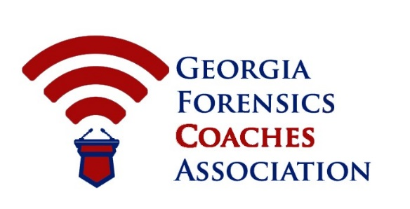
2018 GFCA First & Second Year/Congress State Championships
February 9-10, 2019

Introduction
Attached, you will find all requirements, information, and timeline for the bid to host our State Championship. The instructions following will serve as the basis for evaluating competing bids to ensure that the member school can make commitments to, and follow through on them for the Georgia speech and debate community to provide a successful, efficient, and enjoyable weekend for all participants.

- The Annual First & Second Year State Tournament is a two-day tournament hosted in February every year. This year’s tournament is February 9-10, 2018.

- All bids must be sent to the GFCA Chair of the Committee via google form by September 1st annually. The GFCA Executive Committee urges serious applicants to submit applications as soon as possible, as the host school is chosen on a rolling application system.
- The GFCA Executive Committee may prepare questions for all bidders. The GFCA Chair of the Committee will submit these questions. The GFCA can use the answers to these questions as the basis for further selection or deselection.

- The GFCA Executive Committee will announce the selection of the State Championships by October 15th annually.
- The GFCA Executive Committee will provide the selected host school registration fee waivers and financial assistance for hospitality.

- The host school can earn a $500 stipend in exchange for providing excess judging (8 full judges).

Past Hosts
2006: Carrollton High School (Carrollton, GA). Host: Richard Bracknell
2007: Carrollton High School (Carrollton, GA). Host: Richard Bracknell
2008: Carrollton High School (Carrollton, GA). Host: Richard Bracknell
2009: Carrollton High School (Carrollton, GA). Host: Richard Bracknell
2010: Evans High School (Evans, GA). Host: Steven Hahn
2011: Carrollton High School (Carrollton, GA). Host: Richard Bracknell
2012: Gainesville State College (Oakwood, GA). Host: Tom Preston
2013: Chattahoochee High School (Johns Creek, GA). Host: Garrett Abelkop
2014: Lassiter High School (Marietta, GA). Host: Walter Cotter
2015: Lassiter High School (Marietta, GA). Host: Walter Cotter
2016: Calhoun High School (Calhoun, GA). Host: J. Lane Bearden
2017: Houston County High School (Warner Robins, GA). Host: James Brock

SITE REQUIREMENTS

NON NEGOTIABLE: Internet Access: The host will be required to provide internet access (wireless preferred) for competitors and judges. Internet users must be able to access Google (and Gmail) as well as Slack Team Communications (slack.com).

Competition Rooms: A MINIMUM of 75-80 rooms suitable for debate competitions. In counting your available rooms, remember not to count any which will not be available for security reasons such as computer labs, etc.

Based on 2010-2016 tournament numbers:
  - 20 rooms for Lincoln Douglas Debate
  - 25 rooms for Public Forum Debate
  - 35 rooms for Policy Debate
  - 1 room for 8 persons seated at tables for Tabulation
  - Judge’s Lounges and meeting areas for 75-125 adults

Extra Judges: (NON NEGOTIABLE!) The host school must provide a MINIMUM of five judges. This is IN ADDITION to the team’s normal judge quota based on entries. The committee would appreciate it if the host can exceed this number.

Photocopier: Easy access to a reliable, high capacity machine, with paper. Costs associated with copying are deducted from fee paid to host school.

School Official with Keys: This person must be on call and available throughout the tournament to unlock and relock rooms assigned to the tournament as needed.

Financial Incentive to Host the State Tournament: The host school has three potential areas to make a profit.
- Excess Judging Payment: If the host school can provide excess judging beyond the five required – at least eight total full judges, the school is eligible for a $500 host stipend.
- Concessions, Breakfast items and Saturday Dinner Sales: The host school is responsible for selling concessions and any dinner choices for students on Sunday night which provides opportunity for profit.

