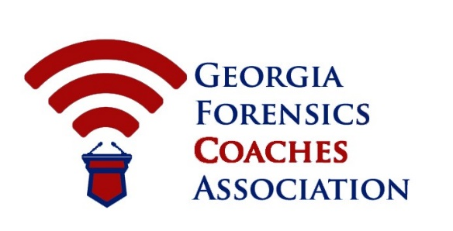
2018 GFCA Varsity State Championships
March 2-4, 2018

Introduction
Attached, you will find all requirements, information, and timeline for the bid to host our State Championship. The GFCA Executive Committee will review all bids submitted to determine their compliance with these instructions. The instructions following will serve as the basis for evaluating competing bids to ensure that the member school can make commitments to, and follow through on them for the Georgia speech and debate community to provide a successful, efficient, and enjoyable weekend for all participants.

- The Annual Varsity State Tournament is a three-day tournament hosted on the second weekend of March every year. This year’s tournament is March 2-4, 2018.

- All bids must be sent to the GFCA Chair of the Committee via google form by July 1st annually. The GFCA Executive Committee urges serious applicants to submit applications as soon as possible, as the host school is chosen on a rolling application system.
- The GFCA Executive Committee may prepare questions for all bidders. These questions will be submitted to the GFCA Chair of the Committee. The GFCA can use the answers to these questions as the basis for further selection or deselection.

- The GFCA Executive Committee will announce the selection of the Varsity State Championships by August 15th annually.
- The GFCA Executive Committee will provide the selected host school registration fee waivers and financial assistance for hospitality.

- The host school will either be able to accept a $500 stipend in exchange for providing excess judging (8 full judges) or collect 90% of the profits made through advertisements for the tournament booklet.

Past Hosts
2011: Georgia Institute of Technology (Atlanta, GA). Host: Shawn Greiner
2012: Westminster Schools (Atlanta, GA). Host: Jenny Heidt
2013: University of North Georgia (Oakwood, GA). Host: Tom Preston
2014: Stratford Academy (Macon, GA). Host: Abby Schirmer
2015: Marist School (Atlanta, GA). Host: Jeffrey Miller
2016: Northview High School (Johns Creek, GA). Host: Ashley Ulrich
2017: Marist School (Atlanta, GA). Host: Jeffrey Miller

SITE REQUIREMENTS

NON NEGOTIABLE: Internet Access: The host will be required to provide internet access (wireless preferred) for competitors and judges to use. Internet users must be able to access Google (and Gmail) as well as Slack Team Communications (slack.com).

Competition Rooms: A MINIMUM of 80-90 rooms suitable for speech and debate competitions, including at least one large room capable of housing about 40 (extemp draw) students. In counting your available rooms, remember not to count any which will not be available for security reasons such as computer labs, etc.

Based on 2010-2017 tournament numbers:
  - 30 rooms for speech events
  - 25 rooms for Lincoln Douglas Debate
  - 25 rooms for Public Forum Debate
  - 15 rooms for Policy Debate
  - 1 room for 25 persons seated at tables (preferably) for Extemp Prep
  - 1 room for 8 persons seated at tables for Tabulation
  - Judge’s Lounges and meeting areas for 75-125 adults

Extra Judges: (NON NEGOTIABLE!) The host school must provide a MINIMUM of five judges. This is IN ADDITION to the team’s normal judge quota based on entries. It would be appreciated by the committee if the host can exceed this number.

Photocopier: Easy access to a reliable, high capacity machine, with paper. Costs associated with copying are to be deducted from fee paid to host school.

School Official with Keys: This person must be on call and available throughout the tournament to unlock and relock rooms assigned to the tournament as needed.

Financial Incentive to Host the State Tournament: The host school has three potential areas to make a profit.
- Excess Judging Payment: If the host school can provide excess judging beyond the five required – at least eight total full judges, the school is eligible for a $500 host stipend.
- Concessions and Saturday Dinner Sales: The host school is responsible for selling concessions and any dinner choices for students on Saturday night, which provides opportunity for profit.

