Teacher Directions:
- Put the first page (What Role…) on the board as a warm-up.
- Have a conversation with the class about the role of the government in the economy.
- Read the second page (Rules of the game…) Since significant = 20% I chose $100 billion as the amount to reallocate.
- Place students in groups of 3-5 students.
- Hand out page 3-4 and some type of counter. I’m using sticky notes.
- Go over the breakdowns of each spending category.
- Let students play the game and reflect on their choices on the handout.

After trying the activity, it took most of 2 days, and students wanted a printout of the budget breakdown (Let’s begin). It worked pretty well, and started a discussion of political motivations and the complexity of federal budget decisions.

WHAT ROLE SHOULD THE GOVERNMENT PLAY IN THE ECONOMY?
From the National Council on Economic Education, New York, NY Civics and Government: Focus on Economics, Unit II, Lesson 4 (http://ecedweb.unomaha.edu/lessons/fecgF.htm)
Although it is generally agreed that there is a role for the government in our national economy, there is considerable disagreement over what areas the government should be responsible for and how far the government should go in these areas. Some people feel that "big government" is a problem-- that government is doing too much. Others believe that the government sector of the economy is being starved and that government should be allowed to do more. What the appropriate role is for government is a basic question, and one that involves a great deal more than economics.
Conservative View
Conservatives believe that the government's role should be severely limited. They feel that economic and political freedom is likely to be undermined by excessive reliance on government. Moreover, they tend to question the government's ability to solve social and economic problems. They believe that faith in the government's power to solve these problems is unreasonable. They
point to the slowness of the government bureaucracy, the difficulty in controlling huge government organizations, the problems political considerations can breed, and the difficulties in telling whether government programs are successful or not. On the basis of these considerations, they argue that the government's role should be carefully limited.
Liberal View
While conservatives question the government's ability to solve important social and economic problems, liberals, on the other hand, question the market's ability to solve these problems. They point to the important limitations of the market system, and they claim that the government can do a great deal to overcome these limitations. Government can regulate private economic activity. It can also provide goods and services that the private businesses produce too little of. Liberals tend to be less concerned than conservatives about the effects on personal freedom of greater governmental intervention in the economy.
Adapted from: Edwin Mansfield and Nariman Behravesh. Economics USA, New York: W.W. Norton, 1992, pp. 592-594.
Question to consider:
1. What is your view of the government’s role in the economy? Do you think the government does more harm or more good in our society? Ask a parent or teacher what their views are on this important question.

Rules of the Game
Introduction:
One of the main areas of debate in Washington involves the federal budget. When the President and Congress make decisions concerning the budget, in essence they are setting priorities for our country. Where should we be investing tax dollars? Which programs should be cut? Which programs should be expanded? Should there be a tax cut and/or a tax increase? Is it okay to continue to run a large deficit?
As you know, the U.S. economy has been in distress. Due to the economic downturn, the government has been collecting less tax revenues and has passed bills to stimulate economic and job growth which have reduced taxes further and added to spending. Additionally, costs for entitlement programs such as Social Security, Medicare and Medicaid have risen. As a result, federal deficits for each of the last five years have exceeded $675 billion. There are different economic arguments about whether running a large deficit is a good idea or not. In the past years, our increase in borrowing was widely seen as a necessary response to a very weak economy. Many economists have argued the necessity of increased government spending as an investment to help our economy grow. You might think of it as the way a family takes out a mortgage to buy a house. Most people think taking out a mortgage is a good idea and an investment in a family’s future. Credit card debt, on the other hand, is something that most families try to avoid as they end up spending needlessly on the high interest on these accounts.
Here is the challenge. After analyzing the FY 2014 budget that President Obama proposed last year, you must design a FY 2015 budget with a group of your peers. You must set the priorities for your administration by looking at the current list of programs and spending and deciding how much to invest in each category. Total government spending for President Obama’s proposed 2014 fiscal year was projected at 3.8 trillion dollars (3,800 billion). Please note that government spending on some programs is fixed by laws and, therefore, cannot be manipulated in the budgeting process. These programs are part of the mandatory budget. The two main programs which are mandatory in the federal budget are Social Security (860 billion dollars—23% of the total spending) and Medicare (healthcare for the elderly—524 billion dollars—14% of the total spending). The net interest on the national debt is estimated at 223 billion dollars—6% of total spending. You will be budgeting for the main programs in the discretionary budget for the FY 2015 budget.
Because of the current resolution that may require cuts in discretionary spending to increase military spending, for this exercise, you will need to reduce discretionary spending by 100 billion dollars. After you have prepared your budgets in your small group sessions, you will need to explain the reasoning behind your budgets to the President.
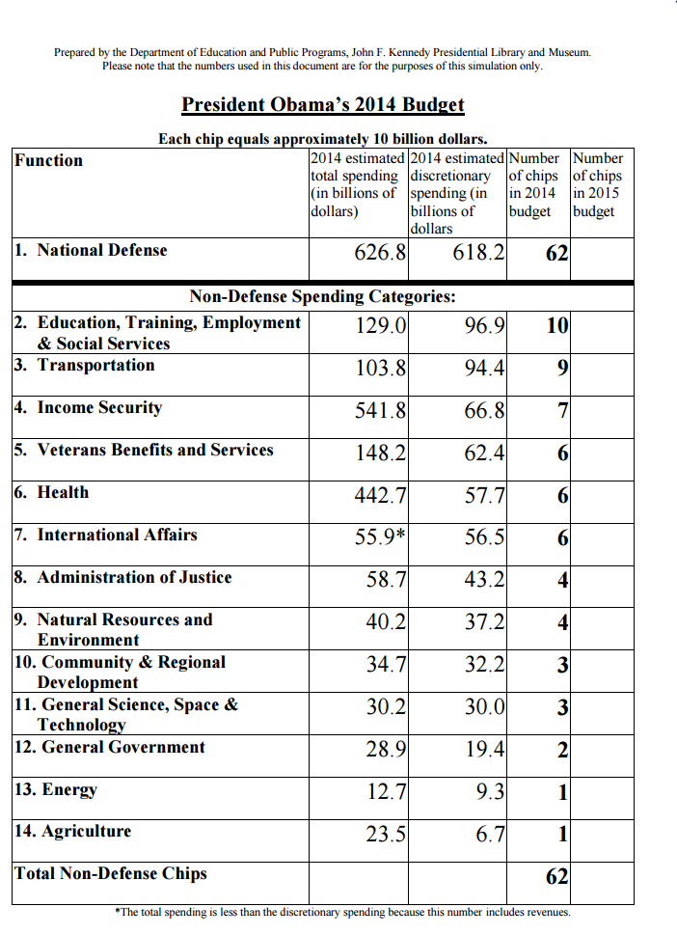National Budget Simulation Worksheet
Name: ________________________________ Date: _________________________
Directions: When you have reached your target, confirm your results of the "Your New Budget" page. When you are finished with the lesson hand the paper that you printed in to your teacher along with this worksheet. Now on the same "Your New Budget" consider your "Spending Changes" and which programs you have cut. This will help you answer the questions below.
1. How will the program cuts that you made affect specific groups (the elderly, students, environmentalists, savers, the poor, foreign aid recipients, producers, etc.)? __________________________________________________________________________________
________________________________________________________________________________________________________________________________________________________________________________________________________________________
2. What programs did you choose to cut? Why did you choose those programs over others? ____________________________________________________________________________________________________________________________________________________________________________________________________________________________________________________________________________________________________________________________________
3. Would other cuts have had less impact on people’s lives? Which budget cuts had the largest impact on reducing the deficit?
____________________________________________________________________________________________________________________________________________________________________________________________________________________________________________________________________________________________________________________________________
4. Which decisions might be perceived as politically motivated? ________________________________________________________
________________________________________________________________________________________________________________________________________________________________________________________________________________________
5. What are the tradeoffs of preserving some programs while protecting others? __________________________________________
________________________________________________________________________________________________________________________________________________________________________________________________________________________
6. How do your decisions result in the marginal benefit to society outweighing the marginal cost to society?
____________________________________________________________________________________________________________________________________________________________________________________________________________________________________________________________________________________________________________________________________
7. If you had the opportunity to raise taxes rather than cut programs, which policy would you choose?
____________________________________________________________________________________________________________________________________________________________________________________________________________________________________________________________________________________________________________________________________
Let’s Begin!
The rules of this simulation are fairly simple. You have 124 white chips (sticky notes) that had been allocated in President Obama’s proposed FY 2014 budget to 14 discretionary spending categories—noted on your worksheet. You should work with your group to allocate funds for FY 2015 based on your group’s discussion of its priorities and values. After discussing your priorities and values,
you will need to consider how you might reconfigure the chips in your budgets, keeping in mind that you must add at least 10 chips from the National Defense category and remove 10 chips from Non-Defense discretionary spending categories. (You cannot move any chips saved in National Defense into Non-Defense categories and vice versa.)
The following are 14 major spending categories with some of the associated functions noted below:
1. National Defense
$618.2 billion in discretionary spending. (62 chips will maintain current level.)
- The raising, equipping, and maintaining of armed forces
- Development and utilization of weapons systems (including nuclear weapons), andrelated programs
- Operations and maintenance of military facilities
- Direct compensation and benefits paid to active military and civilian personnel
- Health insurance and life insurance for military personnel
- Military construction, family housing
- Research, development, testing, and evaluation of new technology and weaponry
2. Education, Training, Employment, Social Services $96.9 billion in discretionary spending. (10 chips will maintain current level.)
- Elementary, Secondary & Vocational education
- Loans, scholarships and stipends for students to participate in education
- Retraining adults for new vocations and employment counseling
- Children and families services programs (including school lunch programs and childcare services)
3. Transportation $94.4 billion in discretionary spending (9 chips will maintain current level.)
- Highways & Highway safety
- Mass transit and railroads
- Air and water transportation (including air traffic control)
4. Income Security $66.8 billion in discretionary spending. (7 chips will maintain current level.)
- Housing assistance for people with low and moderate income
- Food and nutrition assistance to needy individuals
- Low income home energy assistance
5. Veterans Benefits and Services $62.4 billion in discretionary spending. (6 chips will maintain current level.)
- Medical facilities, medical research, and medical care of veterans
- Housing loans to veterans
6. Health $57.7 billion in discretionary spending. (6 chips will maintain current level.)
- Research into the causes and cure of disease
- Substance abuse and mental health services
- Financing specialized programs for training health workers and researchers
- Promotion of consumer and occupational health safety (which includes food safety and inspection against harmful bacteria and bioterrorism)
- Health care to low income, uninsured, vulnerable people who need government support when they become ill
- Funding for the Food and Drug Administration which assures the safety, effectiveness, and security of medications and medical devices.

7. International Affairs $56.5 billion in discretionary spending. (6 chips will maintain current level.)
- Foreign diplomacy (embassies and ambassadors)
- Contributions to International Organizations & Peacekeeping (including support for the UN)
- International financial programs (International Monetary Fund (IMF), etc.)
- Economic and military aid to countries that are friendly to us
- Humanitarian aid to countries that need assistance
- Promotion of democracy and protection of human rights throughout the world
8. Administration of Justice $43.2 billion in discretionary spending. (4 chips will maintain current level.)
- Federal law enforcement and judicial activities
- Federal correctional activities (incarceration of people convicted of federal crimes)
- Grants to state and local governments to assist them in operating and improving their law enforcement and justice systems
9. Natural Resources and the Environment $37.2 billion in discretionary spending. (4 chips will maintain current level.)
- Promotion of conservation
- Controlling and reducing air, water, and land pollution
- Development and maintenance of recreational resources such as national parks
- Work to clean up previously polluted sites, restore them to uses appropriate for surrounding communities, and respond to and prevent waste-related or industrial accidents
10. Community and Regional Development $32.2 billion in discretionary spending. (3 chips will maintain current level.)
- Urban community and economic development programs, such as those providing money for the revitalization of public housing, or money to build affordable housing
- Disaster relief and insurance
- Grants and loans for water supply and sewer systems
- Regional economic development programs
- Aids to businesses such as loans and loan guarantees
11. General Science, Space, and Technology $30.0 billion in discretionary spending. (3 chips will maintain current level.)
- America’s space program
- Grants for cutting-edge discovery in science and engineering
- Grants for improving the quality of math and science education
12. General Government $19.4 billion in discretionary spending. (2 chips will maintain current level.)
- Costs for administering the Internal Revenue Service (IRS)
- Costs for Congress and the Executive Office of the President
- Property and records management
13. Energy $9.3 billion in discretionary spending. (1 chips will maintain current level.)
- Funding for alternative fuel research and development.
- Nuclear waste disposal of commercial (non-Defense) spent nuclear fuels.
- Strategic Petroleum Reserve, which provides emergency oil supply in the event of a severe disruption of supply.
- Funding for energy efficiency and renewable energy.
- Fossil energy programs. (ex., R&D for coal uses)
14. Agriculture $6.7 billion in discretionary spending. (1 chip will maintain current level.)
- Agricultural research
- Meat and poultry inspection
- Agricultural education

