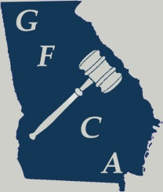

My signature shows that I have read and understand the judge bond agreement.

|  |  |
| --- | --- |
| **Signature** | **Date** |

Your check will cover both the First & Second Year State Tournament and the Varsity State Tournament (if it is not cashed). If your judge bond is cashed as a result of the First & Second Year State Tournament, you will be required to have another judge bond for the Varsity State Tournament. The GFCA will return your check after the Varsity State Tournament if all is cleared. For your judge bond status, please contact Richard Bracknell

_______________________________

Brendon Kendall, GFCA President Richard Bracknell, Treasurer

JUDGE BOND RECIEPT FOR SCHOOL

Make all checks payable to **GEORGIA FORENSIC COACHES ASSOCIATION**

**THANK YOU FOR YOUR ATTENDANCE!**

Georgia Forensic Coaches Association, Inc.

3790 Ashford Dunwoody Dr,

Atlanta, GA 30319

www.thegfca.org

|  |  |
| --- | --- |
| Description | Total |
| Judge & Damage Bond at the GFCA First & Second Year State Championships  *This judge bond should be in a separate check and will only be cashed if one of two things occurs: (1) Damages to the Calhoun High School campus, which requires the GFCA to pay damages, and (2) Your judges miss or delay the tournament and require the Tab Room to replace your judge.* | $100.00 |

**Georgia Forensic Coaches Association**

*Georgia’s Advocate for Speech & Debate*

FEBRUARY 20, 2016