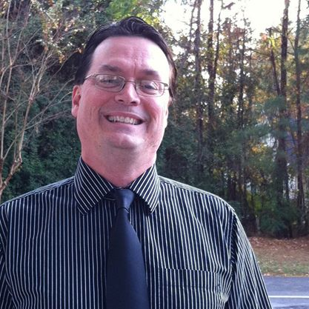
The VSU Forensics (Speech and Debate Team) invite you to our 2015 VSU Blazer High School Invitational. The event will be on Saturday, October 10 on VSU’s campus. Registration will be from 7:00am-7:30am. Please report to the new CAC building lobby (corner of Patterson and Brookwood Dr). Rounds will be in the university center across Patterson. Round 1 will begin promptly at 8am. We cannot delay start since we are offering a one-day only tourney. Pairings will be distributed at the CAC building lobby.
We will be offerring Novice & Varsity Divisions (if entries warrant) in:
▪ Policy Debate ($35) ▪ Lincoln Douglas Debate ($25)
▪ Public Forum Debate ($35) ➢ Congress ($20 per person)
- School Fee: $20 * We may offer extemp/impromptu if enough entries
➢ We will be awarding first and second place sweepstakes winners, team and speaker awards in all debate divisions and at least the first three places in each event (if event makes).
➢ The school’s wireless internet system will have open access in all classrooms.
➢ Hired judges are in short supply. You must specifically request hired judges and we will try to fulfill your requests. Please plan to provide as many judges as you can to fulfill your team’s commitment. Hired judging fee will be 25.00 per debate team; 20.00 per LD, and 10.00 per congress)
➢ Please follow the Georgia Forensic coaches Association rules regarding novice division debaters.
➢ Public Forum and Lincoln Douglas debate will be using the October topics***
The deadline for registration is Monday, October 5, 2015 at 5pm EST. Please email your entries to meaves@valdosta.edu Please do not phone or fax your entries. Full fees will be charged for any students removed from the tournament after this date. Please call or email if you have questions.
Mike Eaves, ph 229-200-8887 (cell), if in dire straits or just need immediate help.
If paying by check, please make payable to: VSU Debate Team –Foundation Discretionary Acct

