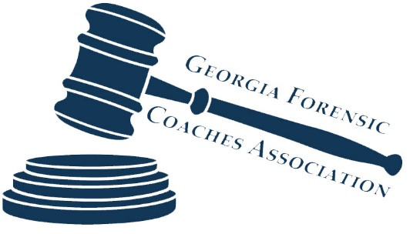
2015 Spring Meeting
Georgia Forensic Coaches Association
Hosted by Alpharetta High School
Room 3212
April 18, 2015

9:00am Welcome & Introductions
Roll Call
2014-2015 Team & Coach Recognition
9:15am Constitutional Amendments (pages 2-8)
Executive Committee Proposal
Fellow Members Proposal
10:00am 2015-2016 Tournament Calendar
Tentative Calendar (Tabroom vs. JOT)
2016 State Championships Format Proposal
2016 State Championships Date Proposal
2016 State Championships Application Proposal
11:00am State Tournament Changes (pages 8-10)
School Definition
Qualification Formula Proposal
Tabulation Formula Proposal
Sweepstakes Proposals
12:00pm Lunch Break
1:00pm Congressional Debate (pages 11-13)
Qualification Formula Proposal
Limits Proposal
2:00pm Business
2015-2016 Novice Packet
2015 Fall Meeting
Principal’s Award Proposal
2:45pm Any other proposals
3:00pm Adjourn

