Evidence Packet
Atlanta Urban Debate League
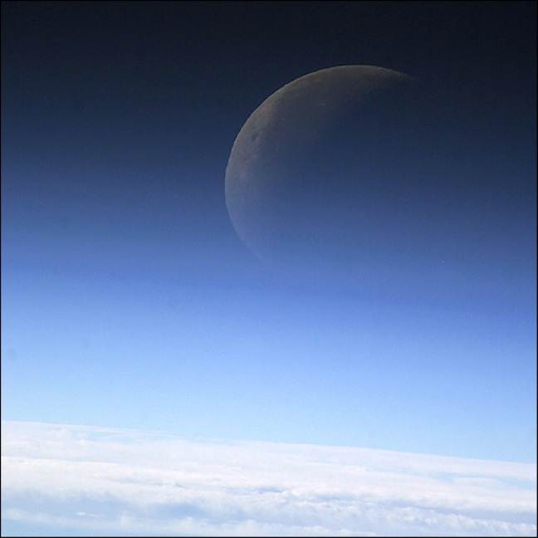
2011-2012
Resolved: that the United States federal government should substantially increase the exploration and/or development of space beyond the Earth’s mesosphere

Glossary

Term | Definition or description
Accelerant | Something that cause something to explode or worsen rapidly
Amenable | Willing to cooperate
anthropogenic | relating to or resulting from the influence that humans have on the natural world
Appropriation | Money for particular purpose
Artifacts | Object made by intelligent life
asteroid | an irregularly shaped rock that orbits the Sun, mostly occurring in a band asteroid belt between the orbits of Mars and Jupiter. Asteroids range in size from the largest, Ceres, with a diameter of 930 km/580 mi, down to dust particles.
Ascending | Moving up
atmosphere | the mixture of gases that surrounds an astronomical object such as the Earth
biosphere | the whole area of Earth's surface, atmosphere, and sea that is inhabited by living things
biotechnology | use of biological processes in industrial production. Early examples of biotechnology include the making of cheese, wine, and beer, while later developments include vaccine and insulin production.
Cascade | a succession of things such as chemical reactions or components in an electrical circuit, each of which activates, affects, or determines the next
Clement | showing or experiencing no extremes in weather conditions
coalition | a temporary union between two or more groups, especially political parties
comet | an astronomical object that is composed of a mass of ice and dust and has a long luminous tail produced by vaporization when its orbit passes close to the Sun
Concurrent | Happening together
constricting | v. tr. 1. To make smaller or narrower by binding or squeezing. 2. To squeeze or compress.
coronal | Part of the sun’s atmosphere
Decimate | Almost destroy something
depression | Prolonged and severe economic slump
desertified | a process by which land becomes increasingly dry until almost no vegetation grows on it, making it a desert
dire | warning of a future disaster or serious consequences
ETI | Extraterrestrial intelligence see extraterrestrial
Ecosystem | An ecological community together with its environment, functioning as a unit.
engulfment | to surround, cover over, and swallow up somebody or something, as floodwaters do
Enclaves | Distinct group in a larger community
Enigmatic | having a quality of mystery and ambiguity and so difficult to understand or interpret
entrepreneur | somebody who initiates or finances new commercial enterprises
episodic | happening at irregular intervals
Escalation | increase
extinct | –adjective 1. no longer in existence; that has ended or died out: an extinct species of fish
Extraterrestrial | Outside earth; space alien
Foetus (British) | Fetus; unborn offspring
Feasibility | the degree to which something can be achieved or put into effect
fiscal | Of the public treasury. Usually refers to tax and spending policies.
Galactic | Relating to galaxy—assembly of stars, gas and dust
Gamma-ray | a high-energy photon emitted after nuclear reactions or spontaneously from the nucleus of a radioactive atom that lowers the energy level of the nucleus. Gamma rays do not carry any electric charge or mass and share the high-frequency end of the electromagnetic spectrum with X-rays, which have similar properties.
Historiography | the writing of history based on scholarly disciplines such as the analysis and evaluation of source materials
hominin | Member of primate family, including humans
Hobbesian | Named after philosopher Thomas Hobbes who theorized that the natural state of things is world where humans compete with one another for resources
hydrated | describes a chemical compound that contains water
Hydrodynamic | relating to the mechanical properties of liquids
imminent | about to happen, or threatening to happen
Immune | Safe from disease
impetus | the energy or motivation to accomplish or undertake something
Implementation | The process of carrying out or fulfilling some obligation or plan of action
Infertile | Barren; unable to reproduce
infrastructure | the large-scale public systems, services, and facilities of a country or region that are necessary for economic activity, including power and water supplies, public transportation, telecommunications, roads, and schools
In-situ | On-site
ISS (International Space Station) | The space station is a joint effort of many nations to be able to conduct experiments in space and advance space technologies for the future. Astronauts can spend weeks and months working at the space station.
Insuperable | impossible to overcome, get rid of, or deal with successfully
Intrinsic | Basic and essential; of itself
Ionising (British) | Ionizing; produce or become ions
kilometer | 1,000 meters/0.621 miles
latency | period of time that something can remain present but unable to develop to its normal state
LEO (low earth orbit) | An orbit in the region of space extending from the Earth’s surface to an altitude of 2,000 kilometers. Given the rapid orbital decay of objects close to Earth, the commonly accepted definition is between 160-2,000 km above the Earth’s surface.
litany | a long and repetitious list of things such as complaints or problems
Maelstrom | Turbulent or violent situation
Malevolence | Harmful or evil
Mesosphere | The mesosphere, which means middle sphere, is the third layer of Earth's atmosphere, between the stratosphere, and the thermosphere. It is located from about 55 kilometers (35 miles) to 85 kilometers (54 miles) above the surface of Earth. Temperature here decreases with height, so within the mesosphere it is warmest at its lowest level (−5°C, or 23°F), and becomes coldest at its highest level (−80°C, or −112°F). Depending on latitude and season, temperatures in the upper mesosphere can be as low as −140°C (−220°F). The temperature in the mesosphere is lower than the temperature of the troposphere or stratosphere, which makes the mesosphere the coldest among the atmospheric layers.
methane-hydrate | a colorless odorless flammable gas that is the main constituent of natural gas. Use: as fuel. Formula: CH4
Microbe | a microorganism, especially a pathogenic bacterium.
microcosm | a miniature representation of something, esp a unit, group, or place regarded as a copy of a larger one
microgravity | a force of gravity so low that weightlessness occurs, e.g. during space travel
Millennia | One thousand years
multilateral | Involving several parties
myriad | so many that they cannot be counted; made up of many different components
nanotechnologies | the art of manipulating materials on a very small scale in order to build microscopic machinery
Nanutubes | a microscopic tube whose diameter is measured in nanometers
NEO (near earth orbit) | Objects that are in are in space sometimes come into close contact with earth.
Neo-mercantilist | New form of commercial enterprise or economic system
nuclear winter | a period of continual cold and darkness believed by some scientists to be a likely consequence of a nuclear war. It would be caused by the blocking of the Sun's rays by high-altitude dust clouds, and would have disastrous environmental consequences.
Opine | To state an opinion
overutilization | using so much of something that it is completely consumed or worthless
Oxygenation | The addition of oxygen to any system, including the human body.
panacea | a supposed cure for all diseases or problems
pandemic | very widespread disease
Partisanship | showing strong and usually biased support for a cause, especially a political one
pathogens | something that can cause disease, e.g. a bacterium or a virus
perils | sources of possible or imagined harm
permafrost | underlying soil or rock that remains permanently frozen, found mainly in the polar regions
Preeminent | standing out among all others because of superiority in a field or activity
Pristine | Unspoiled; in or of original state
probability | statistics the likelihood that an event will occur, expressed as the ratio of the number of favorable outcomes in the set of outcomes divided by the total number of possible outcomes
proliferation | to increase greatly in number
prosperity | Success—usually referring to economic success
Protectionist | An advocate for imposing restrictions on imported goods and services
prudent | Carefully considering consequences
Psychosocial | relating to both the psychological and the social aspects of something, or relating to something that has both of these aspects
pyrotoxin | Poisons released into the atmosphere from massive fires
quantum | sudden, dramatic, and significant
quintessential | Ideal model or type of a thing or event
Recession | A decline in economic activity. Not as along or severe as a depression.
Regolith | the layer of loose rock particles that covers the bedrock of most land on the Earth and the Moon
replete | amply, completely, or fully supplied with something
reservoir | a substantial reserve supply of something intangible
Reticence | disposed to be silent or not to speak freely; reserved.
rogue state | a controversial term applied by some international theorists to states they consider threatening to the world's peace
Sanctity | sacredness
Sapient | Full of wisdom
scenario | an imagined sequence of possible events, or an imagined set of circumstances
Sheathed | Covered; enclosed
Sovereign | Independent; with complete power
Space Shuttle | a reusable spacecraft designed to transport people and cargo between Earth and space, with two solid rocket boosters and an external fuel tank that are jettisoned after takeoff
supernova | a catastrophic explosion of a large star in the latter stages of stellar evolution, with a resulting short-lived luminosity from 10 to 100 million times that of the Sun
Surveillance | Observation; shadowing
survivability | the ability to remain alive or continue to exist.
Sustainability | Ability to be maintained
Synergistic | A combined effort tending to be greater when combined than when separate
synthetic | made artificially by chemical synthesis, especially so as to resemble a natural product
terraform | To transform (a landscape) on another planet into one having the characteristics of landscapes on Earth.
thermonuclear | relating to or making use of nuclear fusion
Topography | Mapping of surface features
Trajectory | Path or process of event
transformation | a complete change, usually into something with an improved appearance or usefulness
transmissibility | the ability to send something, pass something on, or cause something to spread, from one person, thing, or place to another
tsunamis | a large destructive ocean wave caused by an underwater earthquake or another movement of the Earth's surface
Unedifying | Not educational
unilateralist | a person that takes little or no regard of the views of other nations, including allies, or the implementation of such a policy
uninhabitable | Not fit to be lived in
Vector | Disease-transmitting organism (or quantity with direction and magnitude)
Wrangling | Arguing persistently

